How to Open PDF documents in Microsoft Edge

Note: You must have Adobe Reader to open and fill out the forms on your personal computer or laptop. Do not use your mobile phone or iPad.

Step 1: How to check if you have Adobe Reader
- Click on the Search bar at the bottom left of your screen and type ‘Adobe Reader’.
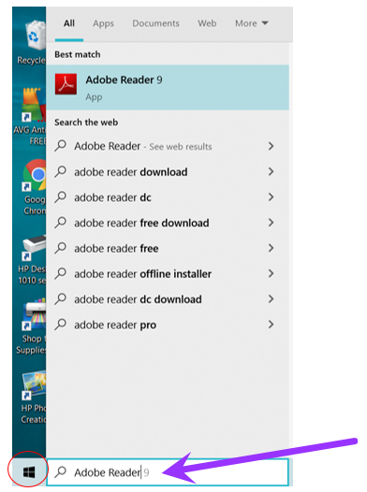

Result: A menu will appear with different tabs.

- Click on the ‘Apps’ tab to view the results.

Note: The Adobe Reader application will be displayed here if you have it installed already. If it does not appear, see below steps for how to install it.

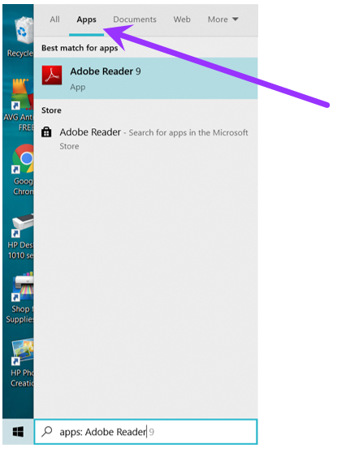

- To install, click here to download a free version of Adobe Reader or any free PDF Reader.

Note: Two options may appear. See below to ensure you choose the correct one.

Select ‘Download Acrobat Reader’.

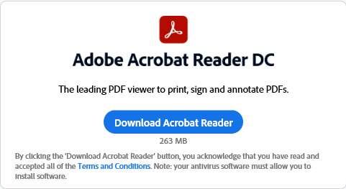

Step 2: Open the Edge browser and click on the form.

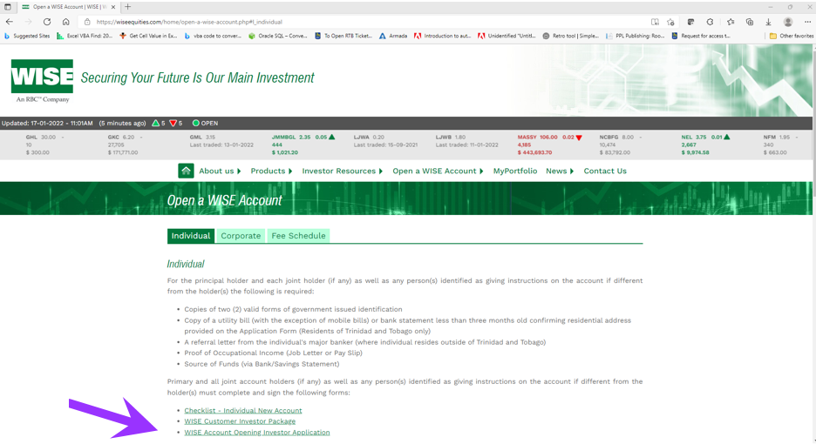

You will receive the following message:
“Please wait…. If this message is not eventually replaced by the proper contents of the document, your PDF viewer may not be able to display this type of document.”
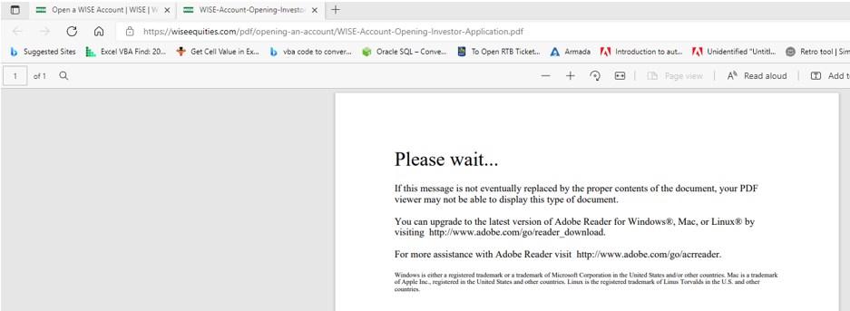
Step 3:
- Copy the form link.

- Open Adobe Acrobat Reader or any PDF Reader.

- Click File, then select Open.

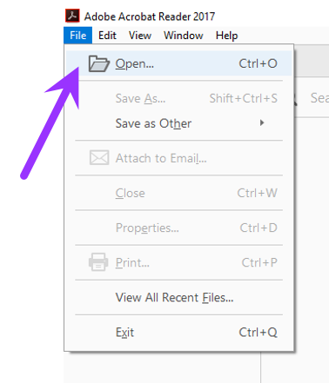

- Paste the PDF link under 'File Name'.
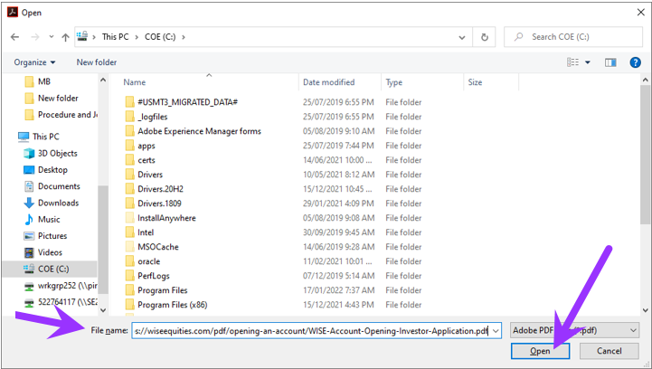

- Click Open.
Result: The file will download and open in Acrobat Reader.

